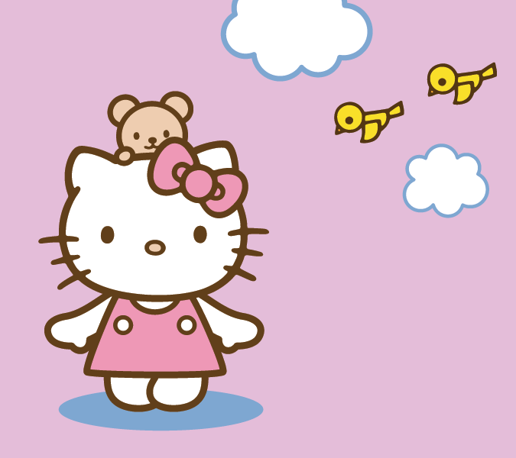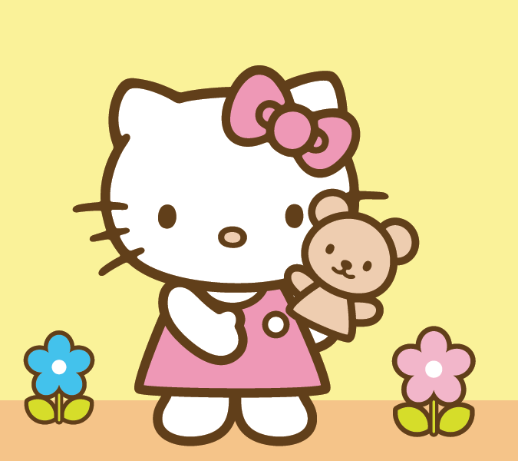 P

Saturday, May 3rd 2013

4423 Sheridan Street Chicago IL

RSVP to Lisa

(123) 456 78 99

JOIN US TO CELEBRATE MARY’S 4TH BIRTHDAY

HELLO KITTY

PARTY